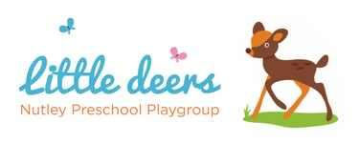

2.3 First Aid

Policy Statement

In The Nutley Preschool, staff are able to take action to apply first aid treatment in the event of an accident involving a child or adult. At least one member of staff with a current first aid certificate is on the premises, or on an outing at any one time. The first aid qualification includes first aid training for infants and young children. We aim to ensure that first aid training is local authority approved and is relevant to staff caring for young children.

Procedures

First Aid Kit
Our first aid kit is accessible at all times, complies with the Department for Education (DfE) and the Health and Safety Executive (HSE) guidance.
It is located in the storage cupboard, opposite the kitchen, top right. It contains the following items:
A leaflet giving general advice on first aid
20 individually wrapped sterile adhesive dressings (assorted sizes)
2 sterile eye pads
2 individually wrapped triangular bandages (preferably sterile)
6 safety pins
6 medium-sized individually wrapped sterile unmedicated wound dressings
2 large sterile individually wrapped unmedicated wound dressings
3 pairs of disposable gloves
1 plastic disposable apron
A children’s digital thermometer

- The first aid box is easily accessible to adults and is kept out of the reach of children.
- The contents of the boxes are checked on a termly basis and the check sheet signed by the designated checker and who is responsible for replacing any items used or out of date. This is to check stock levels and ensure all contents are still in date.
- No un-prescribed medication is given to children, parents or staff.
- At the time of each child’s admission to the setting, parents' written permission for obtaining emergency medical advice or treatment is sought. Parents sign and date their written approval.
- Parents sign a consent form at registration allowing staff to take their child to the nearest Accident and Emergency unit to be examined, treated or admitted as necessary on the understanding that parents have been informed and are on their way to the hospital.

