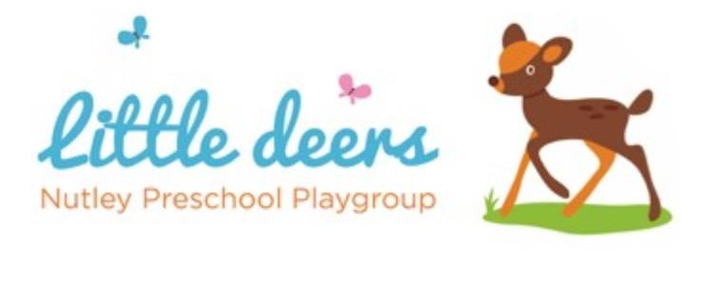

2.4 Food, Drink, Allergies and Safer Eating

Little Deers Nutley Preschool
Policy adopted: July 2026
Date for review: July 2027
Person responsible: Preschool Manager

Policy statement
Nutley Preschool regards snack and lunch times as an important part of the day. Eating is a social time for children and adults and helps children learn about healthy eating, independence and safe routines.
We promote healthy eating and aim to provide food and drink that meets children’s individual dietary needs, preferences, allergies and intolerances.
We recognise that allergies and choking risks can be serious. We therefore ensure that food is checked, prepared and supervised safely.

This policy should be read alongside First Aid, Administering Medicines, Food Hygiene, Health and Safety, Risk Assessment, Safeguarding, and Managing Children who are Sick, Infectious or with Allergies.

Procedures
Before a child starts at the setting, we ask parents and carers about dietary needs, preferences, allergies, intolerances, medical needs and cultural or religious requirements.
This information is recorded on the child’s Registration Form and parents sign to confirm it is correct.
We regularly ask parents to update dietary and allergy information. Parents must tell us immediately if anything changes.
Current dietary and allergy information is made available to all staff and volunteers who need to know.

Allergies and intolerances
Where a child has a known allergy or significant intolerance, we will agree an allergy action plan with parents and carers.
The plan will include:
- the allergy or intolerance;
- symptoms to look for;
- foods or substances to avoid;
- medication needed, if any;
- emergency action;
- parent/carer contact details.
All staff will know where allergy information and medication are kept.
Staff will be sensitive when supporting children with allergies, intolerances or dietary requirements. Children will not be labelled or made to feel singled out.
Food checks
At each snack time, lunch time or food-related activity, a named member of staff will check that food and drink are suitable for each child before it is served.
Staff will check:
- allergies and intolerances;
- parent preferences;
- cultural or religious requirements;
- choking risks;
- ingredients in food brought in for sharing.
We discourage children from sharing or swapping food.

Food provided by the setting
We provide nutritious snacks, avoiding large amounts of saturated fat, sugar, salt and unnecessary additives.
We take care not to provide food containing nuts or nut products and are especially vigilant where a child has a known nut allergy.
Fresh drinking water is available at all times. Children are told how to access water and can ask for water at any time.
For young children who drink milk, we provide semi-skimmed milk.

Safer eating and choking prevention
Children are supervised while eating and remain within sight and hearing of staff.
To reduce choking risks:
- children sit down while eating;
- staff sit with or near children during snacks and lunch;
- children are encouraged to eat calmly and not rush;
- food is prepared appropriately for children’s age and stage;
- grapes, blueberries and similar foods are cut lengthways;
- children are not left alone with food.
Any choking incident requiring staff support will be recorded and parents will be informed.

Snack time
Snack times are social occasions where children and staff participate together.
Children are supported to develop independence by making choices, serving food and drink where appropriate, and feeding themselves safely.

Lunch Club
Parents providing packed lunches are encouraged to include healthy foods, such as sandwiches or similar, fruit, and milk-based desserts such as yoghurt.
Parents should:
- avoid nuts and nut products;
- cut grapes, blueberries and similar foods lengthways;
- use suitable food containers;
- include an ice pack where food needs to be kept cool;
- avoid lunches made up mainly of crisps, processed foods, sweet drinks, cakes or biscuits.
We reserve the right to return unsuitable food to parents as a last resort.
Staff sit with children during lunch so that the mealtime is safe, supervised and social.

Food brought in from home
Parents are informed about food storage facilities and suitable containers.
Where birthday cakes, treats or food for sharing are brought in, staff will check ingredients before offering them to children. A healthy snack will always be offered before any treat.
Food may be refused if ingredients are unclear or if it presents a risk to a child with allergies or dietary needs.

Food activities
Cooking, baking, tasting and food-based sensory activities will be checked in advance against children’s allergies, intolerances and dietary needs.
Suitable alternatives will be used where needed so children can be included safely.

Records
We keep records of:
- dietary needs, allergies and intolerances;
- allergy action plans;
- medication information;
- changes shared by parents;
- allergic reactions;
- choking incidents;
- first aid or medication given.

Review
This policy will be reviewed annually, or sooner if EYFS requirements, food safety guidance or setting practice changes.

