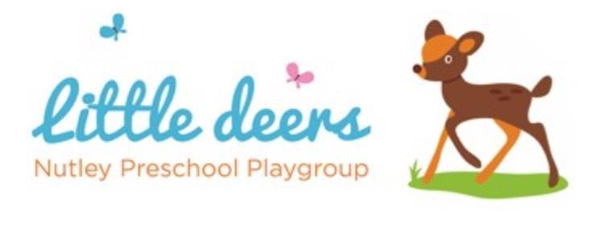
2.6 Animals in the Setting

Little Deers Nutley Preschool
Policy adopted: 01/08/2026
Date for review: 01/08/2027
Person responsible: Preschool Manager

Policy Statement
Children learn about the natural world, animals and other living creatures as part of their learning and development. This may include contact with animals at Nutley Preschool, during visits, or as part of planned activities.
We aim to ensure that any contact with animals is safe, supervised, hygienic and appropriately risk assessed.
This policy should be read alongside Health and Safety, Risk Assessment, Safeguarding, Food Hygiene, Allergies and Safer Eating, and First Aid.

Procedures
Animals may only be brought into the setting with prior agreement from the Manager.
Before any animal visit or activity, the Manager or Deputy Manager will complete a risk assessment considering:
- the type, size and behaviour of the animal;
- supervision arrangements;
- children’s allergies, phobias, SEND or medical needs;
- hygiene and handwashing;
- infection control;
- bites, scratches or stings;
- safe handling;
- suitability of the space;
- parent communication where needed.
Children will always be supervised when near animals.
Children will be shown how to behave calmly and kindly around animals. They will not be allowed to tease, chase, pull, feed or handle animals unless this has been agreed and is closely supervised.
Children and staff will wash their hands after touching animals, animal bedding, food, cages, tanks or equipment.
Animals will not be allowed in food preparation areas, eating areas, toilets, nappy changing areas or sleep/rest areas.
Any bite, scratch, sting, allergic reaction or other incident will be treated under First Aid procedures, recorded, and reported to parents/carers.

Dogs and banned dog breeds
No banned dog breed, as defined by current UK law, may be kept or present on the premises at any time while registered childcare is being provided.
This applies even if the dog has a certificate of exemption.
Parents, carers, staff, visitors, contractors and volunteers must not bring banned dog breeds onto the premises, including at drop-off, collection, events or visits.
Any other dog brought onto the premises, including an assistance dog, must have prior agreement from the Manager and be risk assessed.
Dogs must remain under close control at all times and must not have unsupervised contact with children.

Visits involving animals
Where children visit places with animals, such as farms, parks or animal centres, staff will complete a visit risk assessment in advance.
The risk assessment will include supervision, handwashing facilities, contact with animals, food and drink arrangements, allergies, safe routes and emergency procedures.
Children will wash their hands before eating and after touching animals or animal areas.

Records
The setting will keep records of:
- animal visit risk assessments;
- parent communication where needed;
- allergies or individual child concerns;
- accidents, incidents or first aid;
- any decision to refuse or stop an animal visit.

Review
This policy will be reviewed annually, or sooner if EYFS requirements, legislation, health and safety guidance, or setting practice changes.

